Anti drug seminar and quiz programme -26/6/2019
Nss unit and Excise office punalur jointly organized a seminar and quiz programme to create awareness among students regarding the importance of a drug free society.It was inaugurated by the college principal ,Dr.K.P.Laladhas .Quiz programmes were arranged by Vimukti mission co-ordinator ,kollam.The pledge on Anti drug day was also taken.

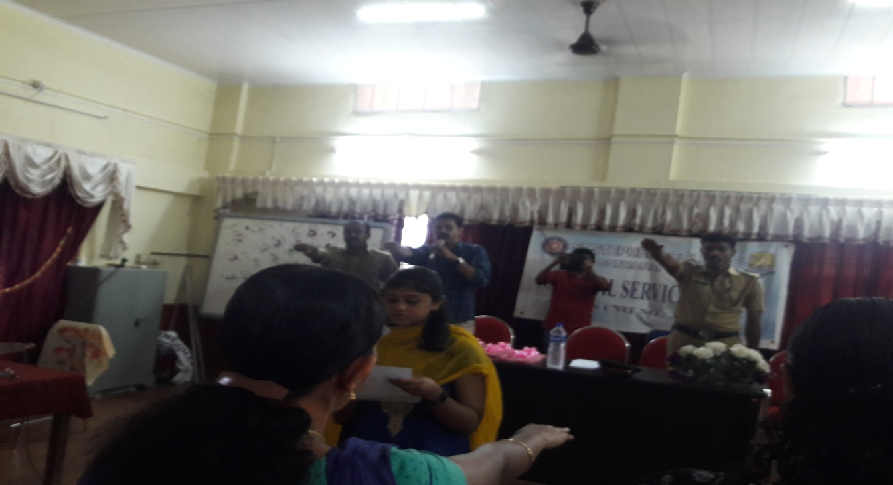

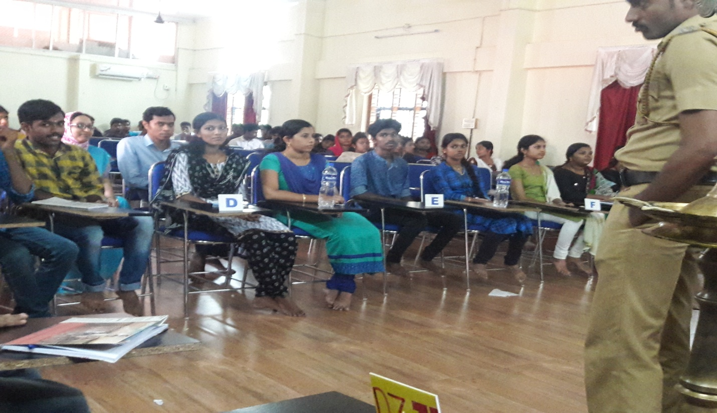

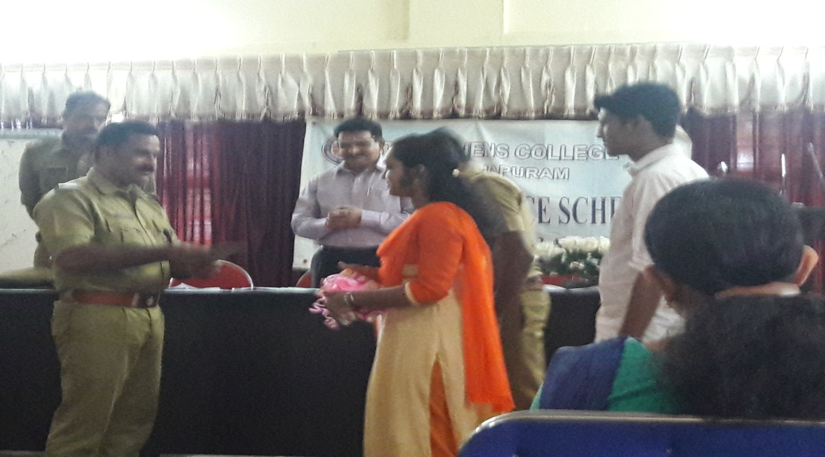
Street play against drug abuse in campus- 25/09/2019

It was done in association with ICPF for creating an awareness among students regarding drug abuse. Later a power point presentation was also done .

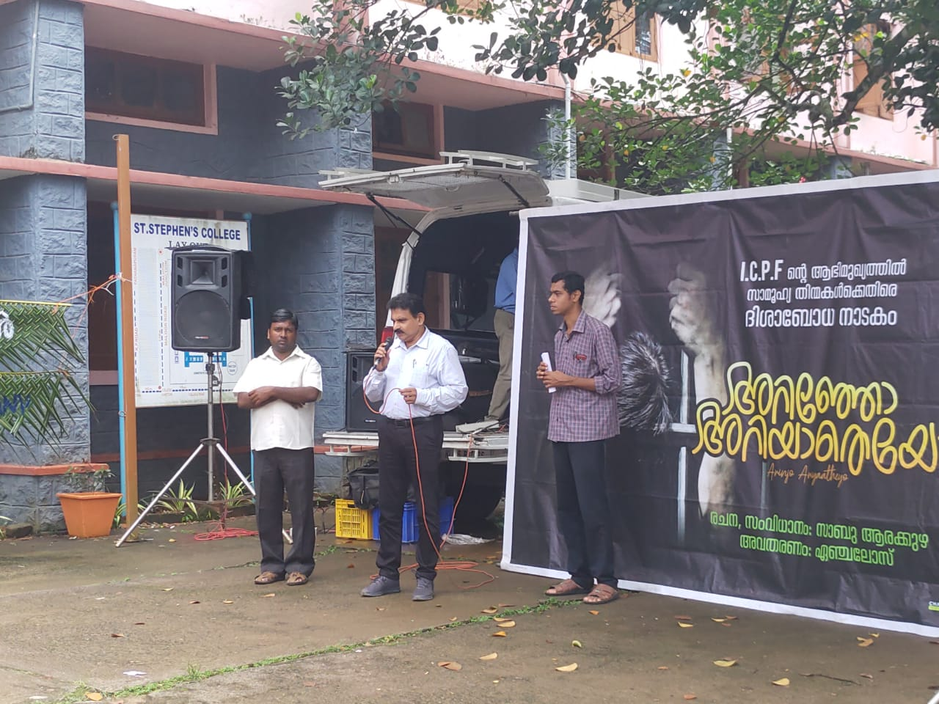
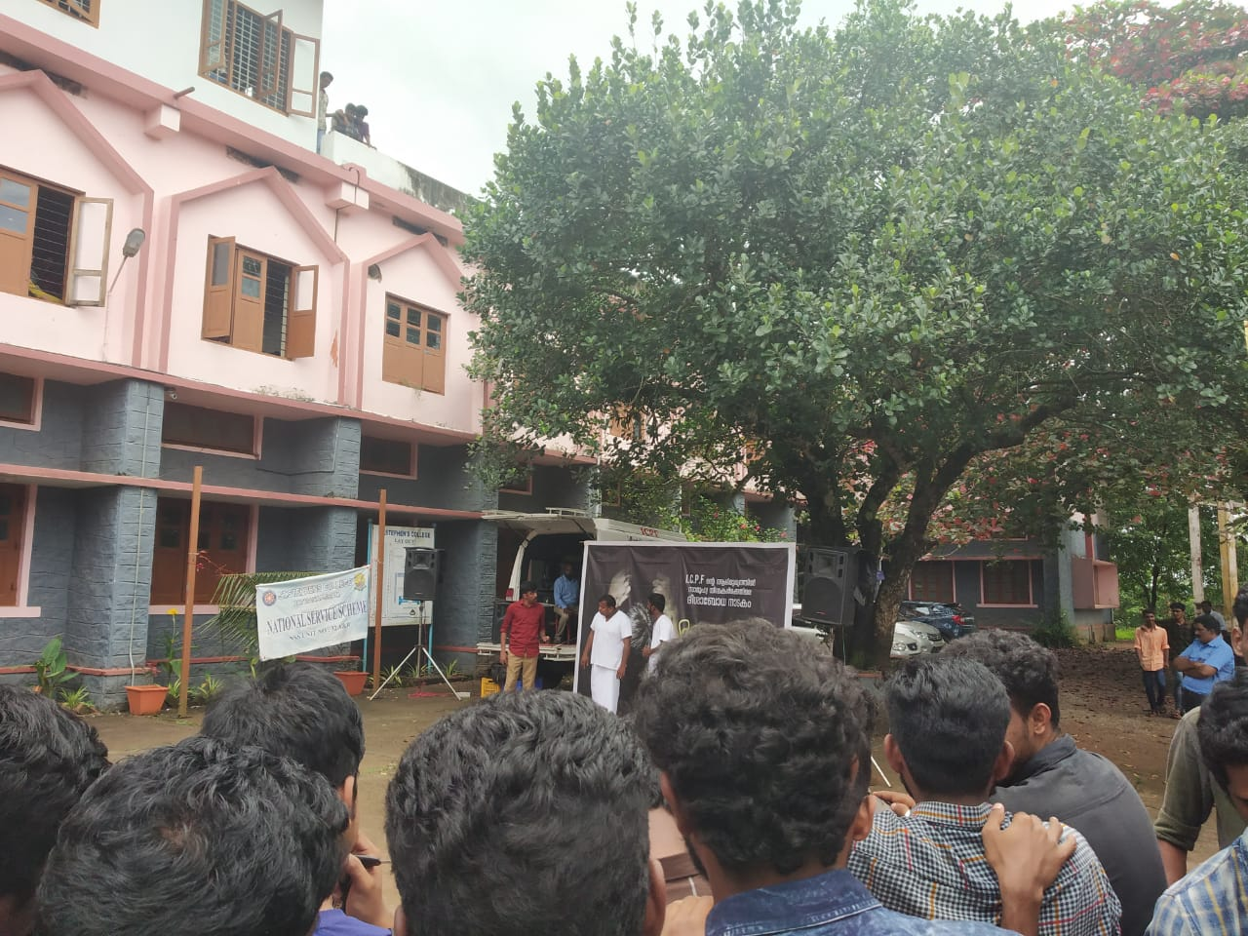

Two day residential training on anti drug initiative 21-22 November 2019
A two day residential training programme on anti-drug initiative on 21-22 November 2019 at Kerala University Students Centre, PMG, Thiruvananthapuram. The programme is implemented by the National Service Scheme, University of Kerala in association with Kerala Excise Department.1 NSS volunteer from the college participated.

Vimukthi campaign and survey 21/12/2109 and 22/12/2019
. The Government has launched ‘Vimukthi‘ (Kerala State Mission for De-addiction), a new project to conduct awareness campaigns against alcoholism and drug abuse. It is being implemented with the help of National Service Scheme, in colleges and nearby place. Addiction free Kerala is the aim of this mission. Statewide campaigns to make students and youth aware of the evils of drug addiction and alcoholism will be conducted.
A survey was conducted by NSS Volunteers with the help of Pathanapuram excise office as part of vimukthi campaign .The students took a survey of 109 houses in V and VI ward of Pattazhy Vadakkekara panchayat .Out of the survey conducted ,42% of the houses had been suffering from one or another form of drug addiction .Most of these houses belong to backward class family. The evil effect of narcotics is considered as the main reason for the backwardnesss of the family. It is also understood that most of the families did not participated in any of the anti drug campaign programmes organised by the government.
The survey outlined a society of people including an average and backward financial background.One of the findings of survey is that the alcoholic beverages ,such as alcohol and cigarattes play an important role in the rconomic vulnerability of families .It is a matter of great concern that in addition to disturbing the peace and tranquillity within the family and creating interpersonal disturbances the psychological and physical health of students involved is greatly affected .Excise officer throughout the 2 consecutive days served as guides to students and together distributed the palmphlets and card which ensures an alcohol free house.
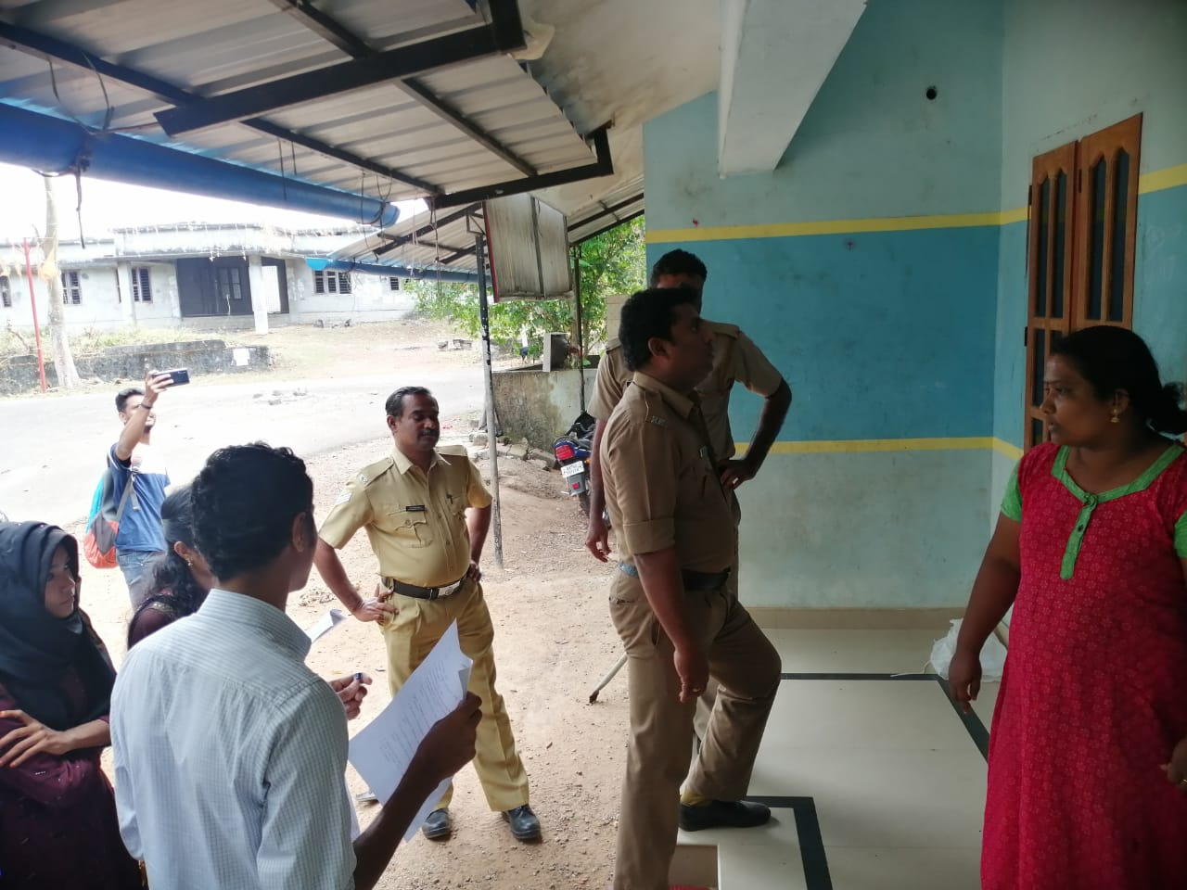
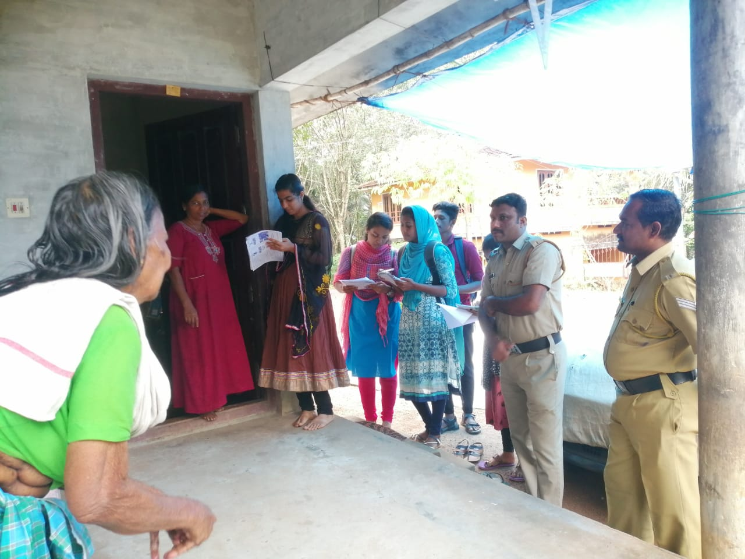

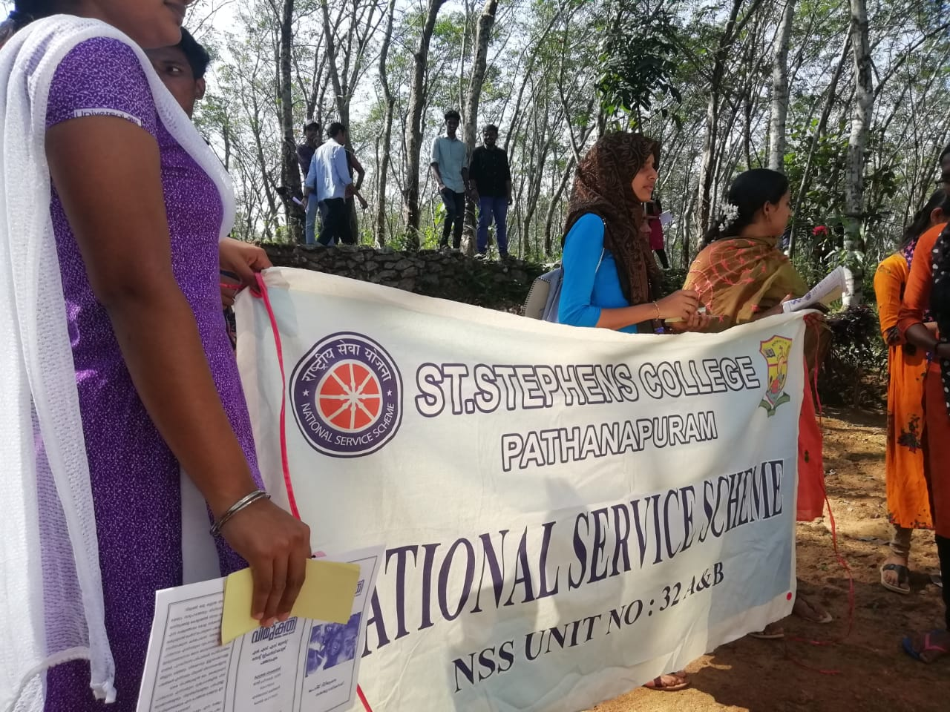

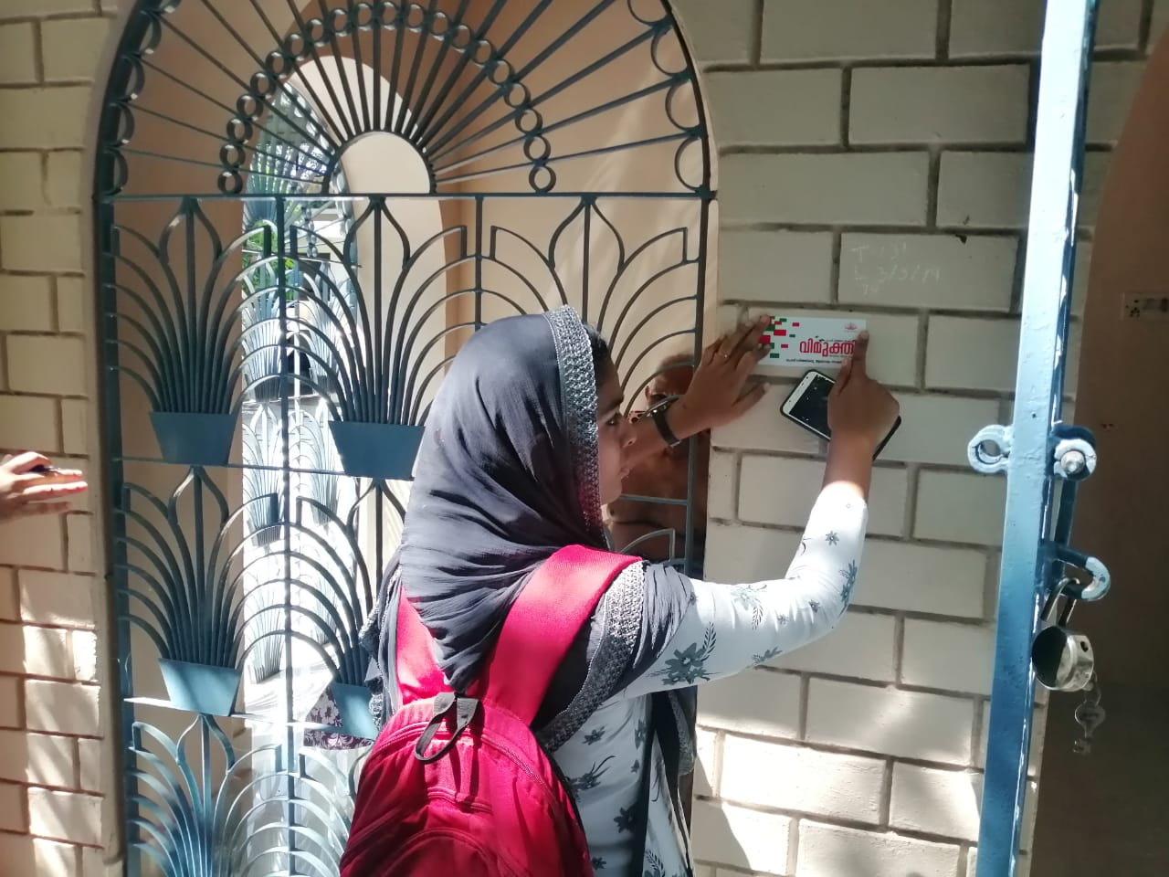

Flash Mob 25/1/2020
A flash mob was conducted on January 25th in association with excise office in kallumkadavu near pathanapuram .It intended to raise the public awareness regarding anti drug campaign. It showcasd a 15 minute energetic performance by NSS volunteers through songs, dialogues and placards.The programme was inaugurated by excise range officer Benny George.

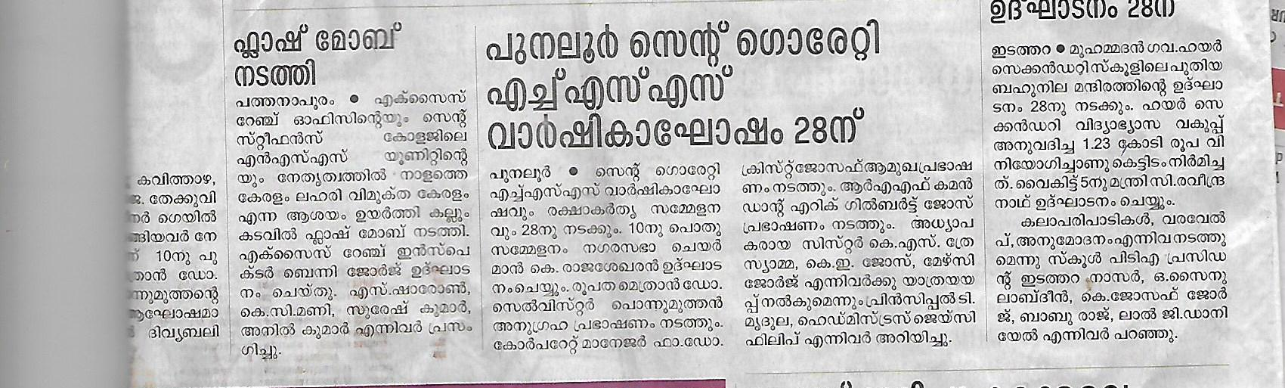
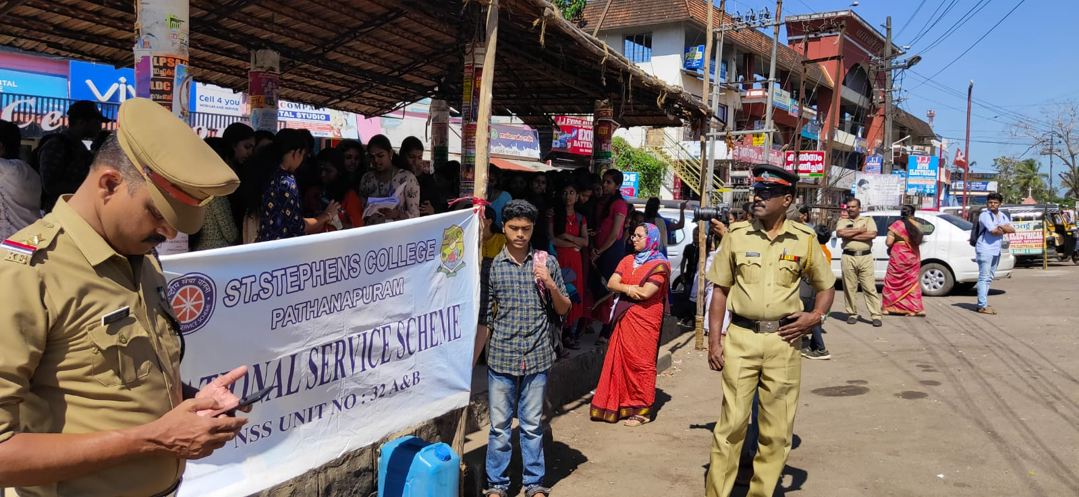

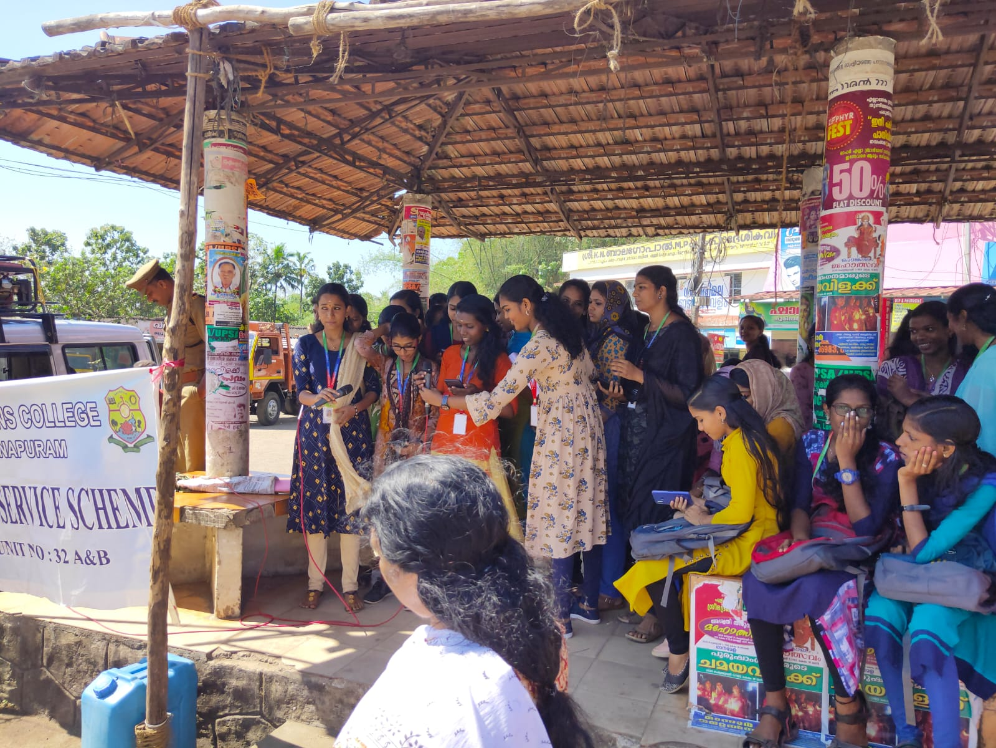

Short film production
A short film was produced depicting the evil effects of drug abuse among youths in colleges.It was named as “Athijeevanam”

